**Why are we doing this?**

This is my first project for the QA DFEW4 cohort. This project shall display both Frontend/Backend Software development. Additionally it shall produce Unit, System and User Testing.

Coverage at 91% for Junit and Integration testing

Employee Management Application Task- Attempted by Chibueze Ogu.

This application is designed to manage employee database, therefore it has a consistent CRUD functionality. A user is designed to log in into the database and then update and create their information within a local database (H2 has been enabled via the pom.xl file in this instance. This information is relayed from the initial Java/SpringBoot code within the java .jar file provided. It then links to a main port within your system (port 8080 was used extensively during this project, but you can change this is so desired to a more compatible port). The Frontend contains fetches which catches the API links and enables the cross of hands between the front-end and backend. This project has full CRUD functionality within the Java and Spring aspect.

**How I Expect the challenge to go?**

At the initial start of the project, I expected I will get significant help and support from the tutor as well as the DFEW4 team. I knew right from the beginning of the Java course module that I will be challenge significantly in regards to grasping and understanding the concepts. I was in full expectation that it will require me further spend time in reading and watching videos from other relevant materials. I allocated more time to learn the concepts and basis of the module. I must admit it was indeed a challenging task and while doing the project I was in constant doubt with myself and what it is I was doing.

**What went well?**

* Springboot Application initialising
* Data persisting on postman
* Jira project management board
* Risk assessment

**What didn’t go as planned?**

* System Failure was required to restore my system
* Springboot Application failed to initialise.
* Struggled with identifying the right codes and various annotations for the project
* Had several test failed result
* Struggled with identify the project scope before righting codes.

**Possible Improvements for future revision of the project?**

* **Develop a more robust data management application for employee including other features**

**Screenshots showing postman request/Data Persisting**

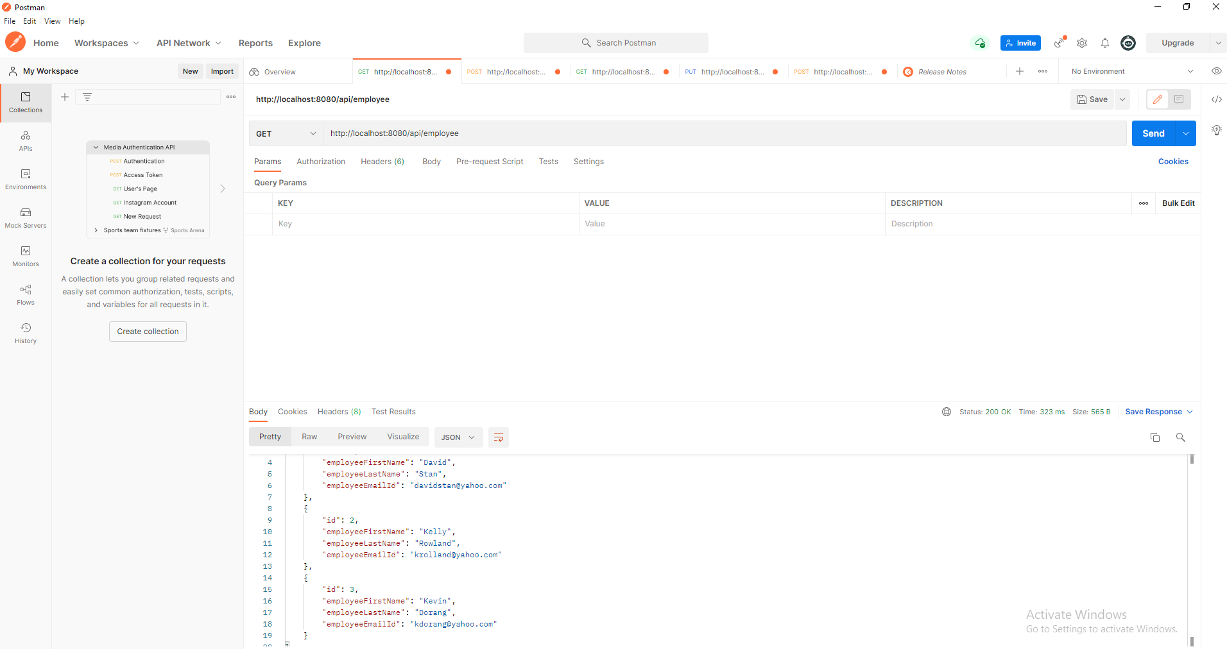

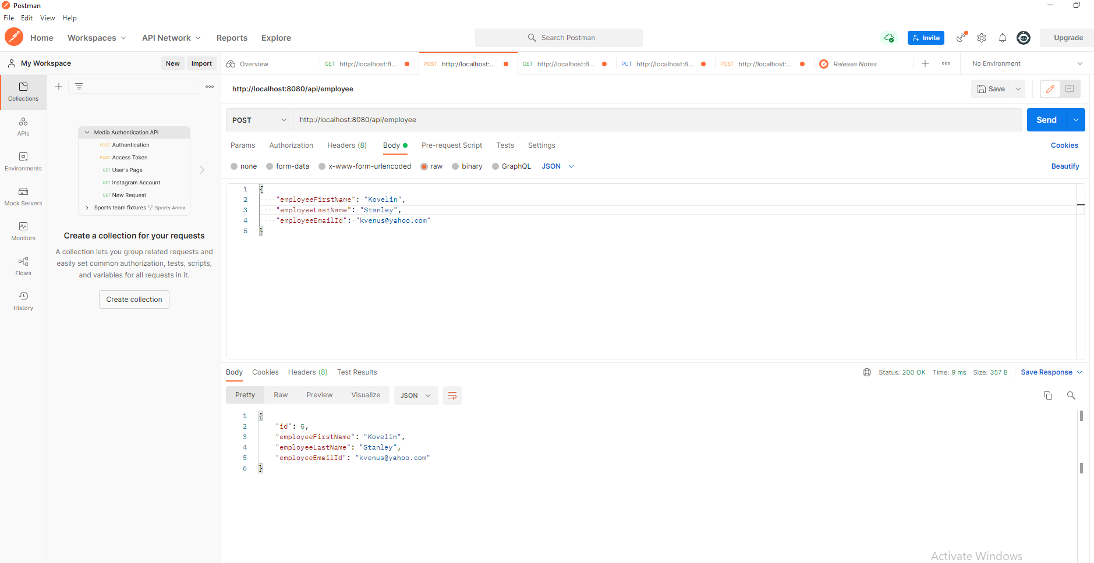

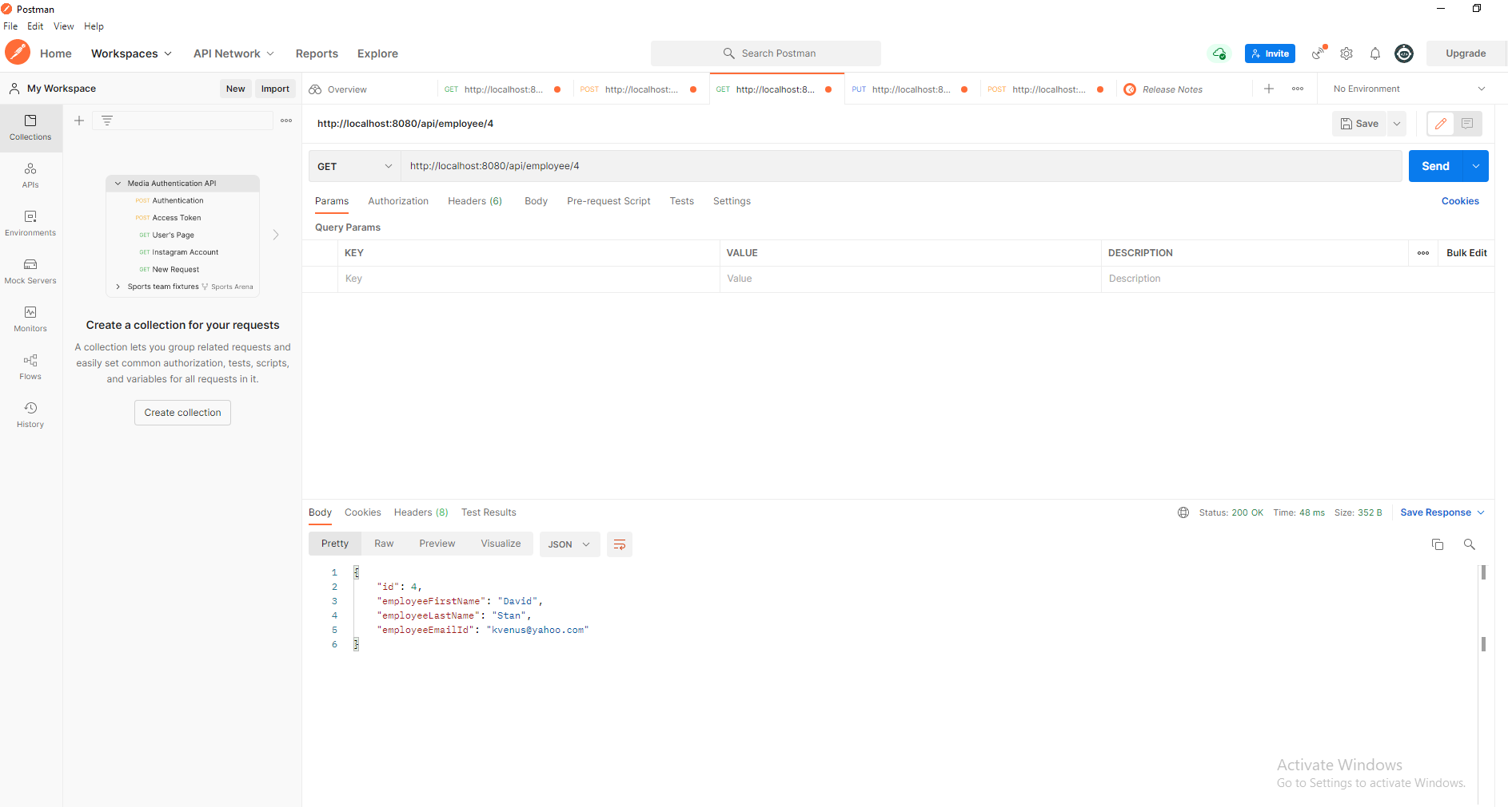

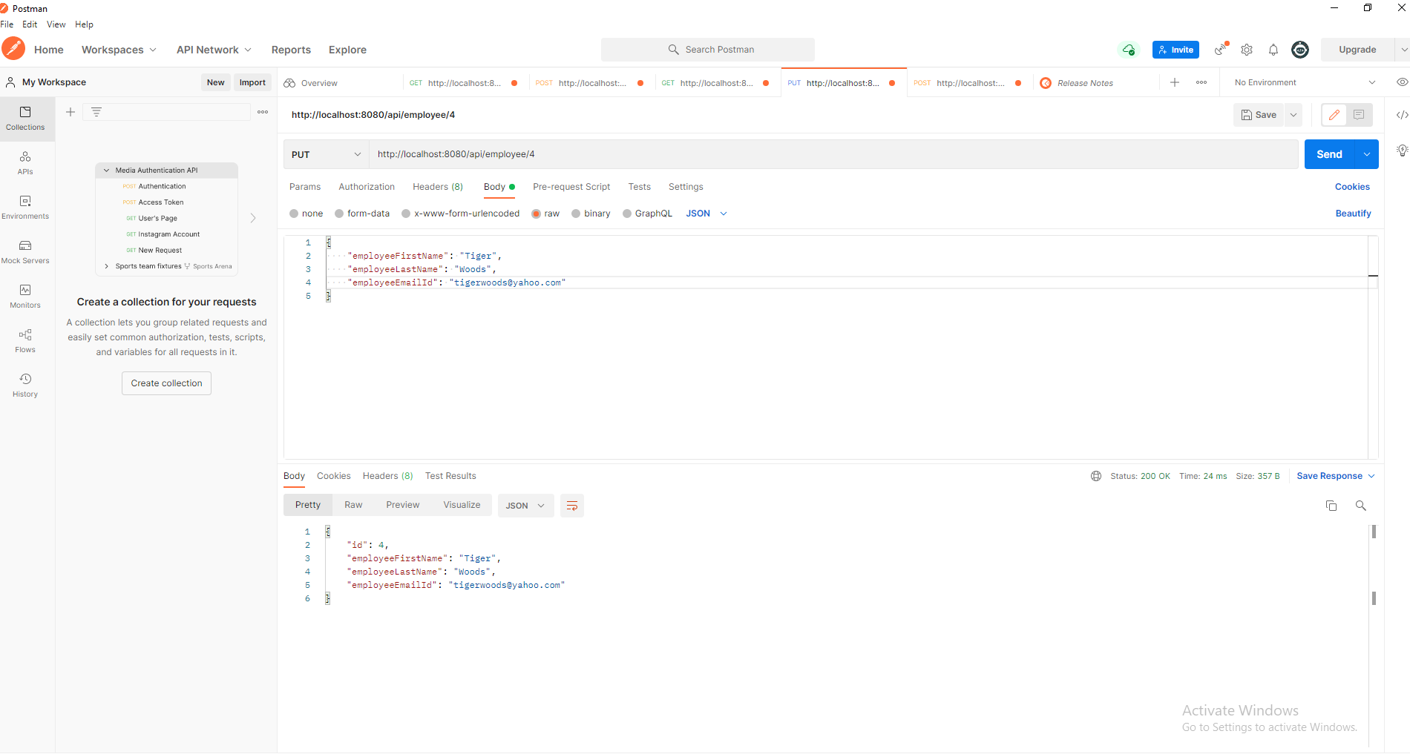

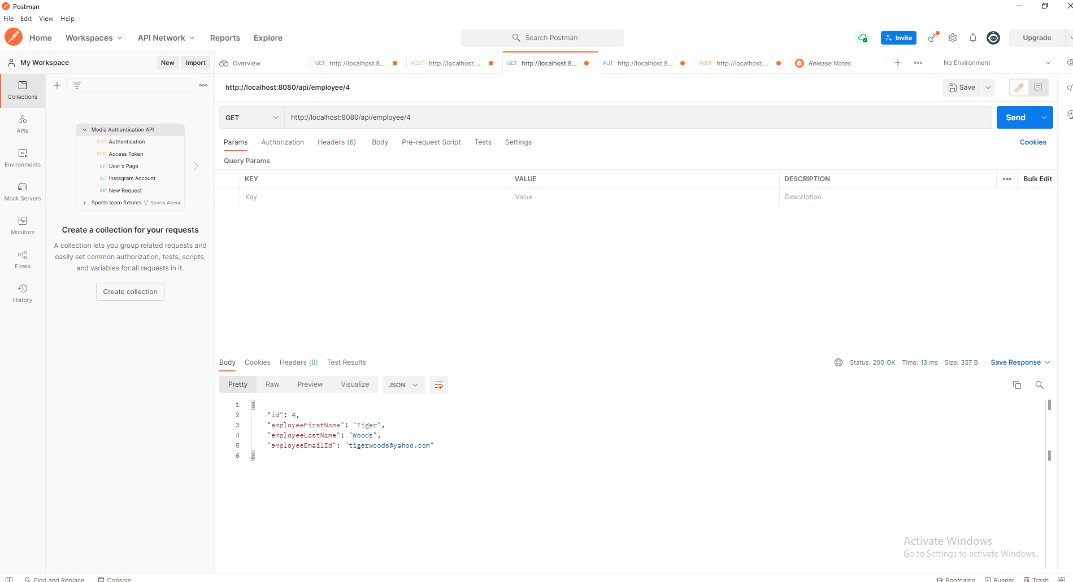

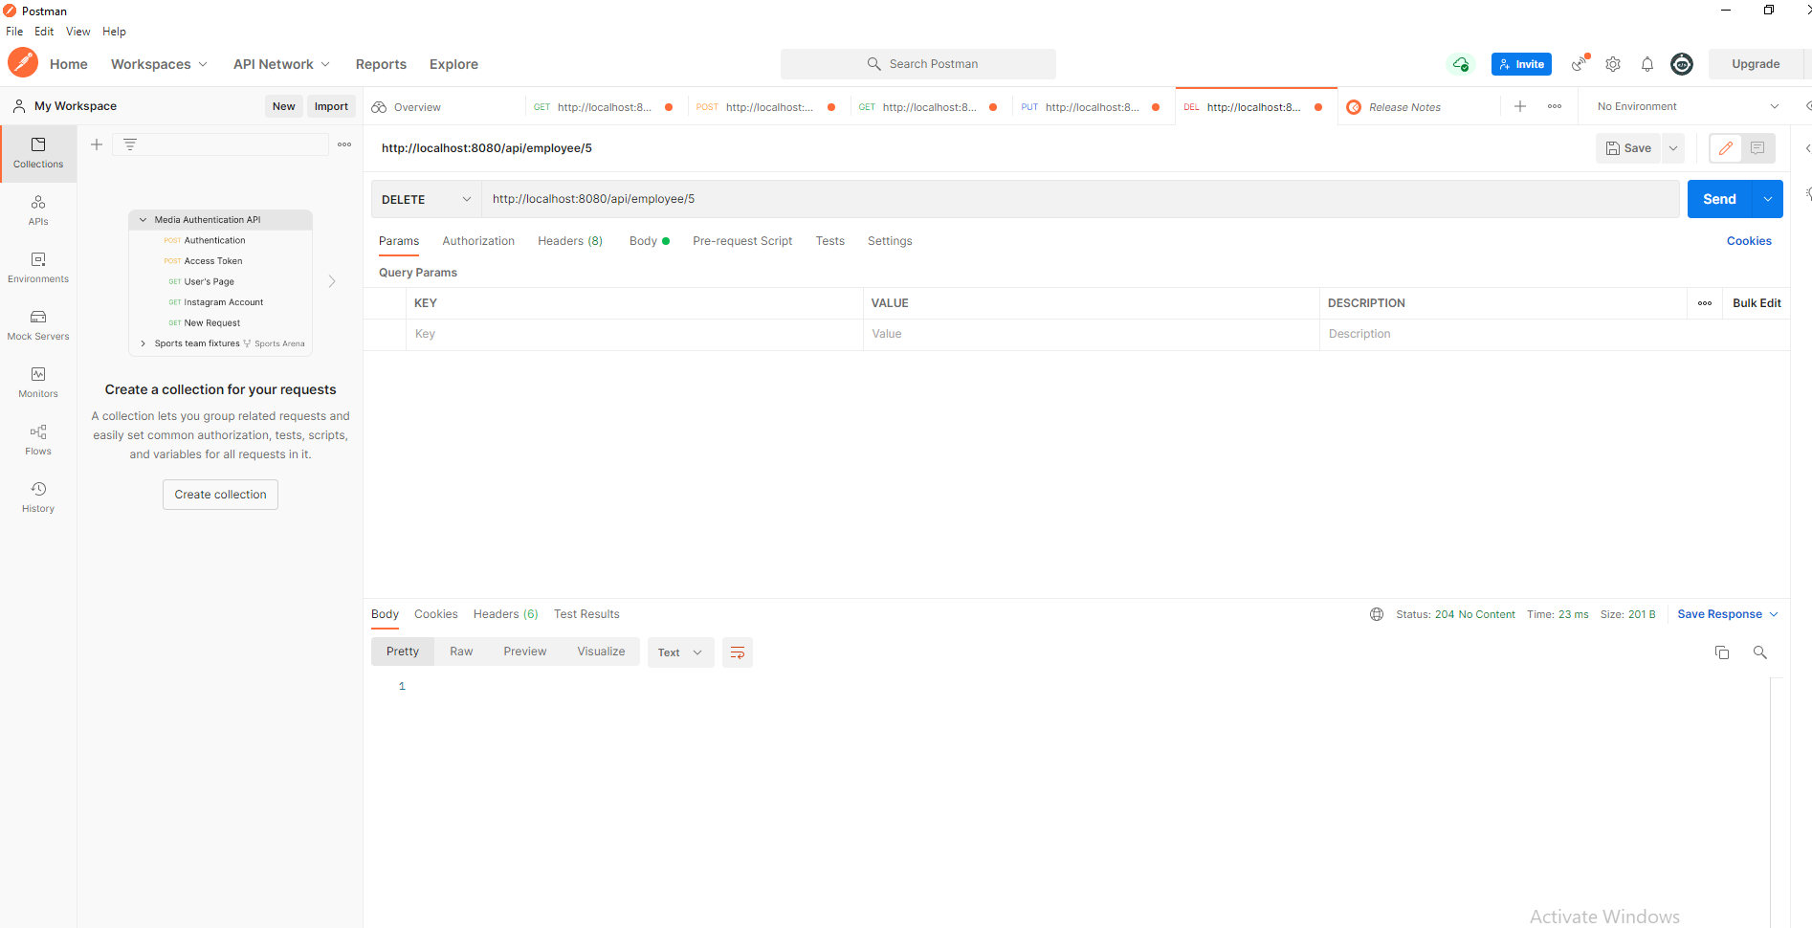

**Screenshots of test results (Coverage report)**

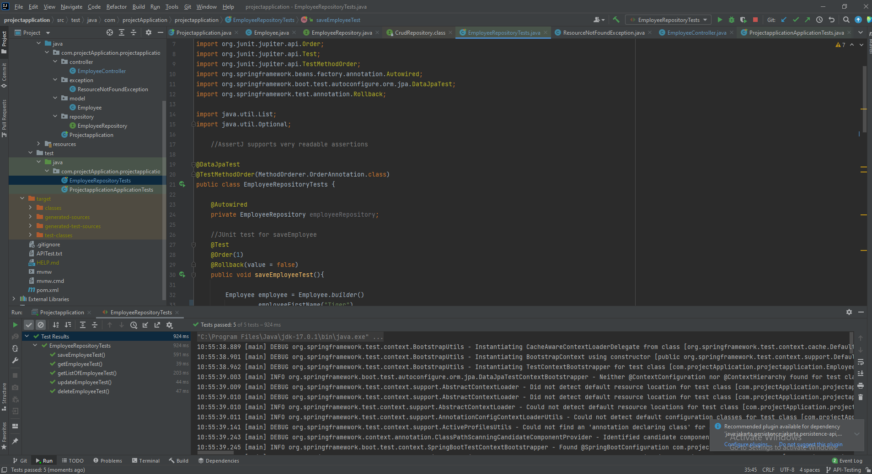

**Tools Used**

Eclipse Maven Jira (Agile Project management -) JUnit Mockito Postman Java Microsoft Excel (Risk Matrix).

**Built With**

* [Maven](https://maven.apache.org/) - Dependency Management

**Authors**

Chibueze Ogu

**Jira Link**

[**https://chizorma01.atlassian.net/jira/software/projects/EMA/boards/3/backlog?selectedIssue=EMA-15**](https://chizorma01.atlassian.net/jira/software/projects/EMA/boards/3/backlog?selectedIssue=EMA-15)